

Creditworthy Company
8103 SW Sacajawea Way
Wilsonville, Or 97070
503-694-5897
Richh@creditworthy.com
Creditworthy is subsidiary of NACM Tampa



Industry Credit Groups are an important part of Business Credit for many credit professionals. Groups are formed to allow Credit Managers to meet, discuss issues and to exchange experience on mutual customers within the same industry.
Creditworthy has combined the internet and advanced database programming to improve information gathering, storage and delivery to group members. The result is like combining the best of a credit group with your own industry credit reporting agency.
As the Credit Manager, you have the responsibility for managing the account receivables of your company. That means promoting sales and being responsible for selling to customers that meet the company’s criteria for creditworthiness. In order to perform your duties, you work hard to obtain good, solid credit information that helps to determine the creditworthiness of your customers.
Part of your research may include obtaining financial information, bank experience or pay history from vendors that have sold to your customer in the past. Trade experience can be obtained through credit reporting agencies, directly from the vendor or from participating in an Industry Credit Group where trade experience is exchanged between the members.
Industry Credit Groups have existed for decades with a great deal of success, but Creditworthy Company has improved the benefits by creating a web based program to manage all aspects of the group. The members are now able to access the program to obtain customer information from anywhere in the world - things only dreamed about Credit Managers just a few short years ago.
A partial list of the functions now include:
1) alerts, 2) requesting and remitting trade experience when required, 3) meetings,
4) manual or electronic submission of trade experience, 5) internally generated credit reports, 6) access to public company information such as financial statements, charts and news, 7) customer reports,
8) account monitoring and more.
TAKE A TOUR
In order to get a feel for what the program does, lets take a quick tour. When you and other authorized members of the group login to the program, you will arrive at “Group Headquarters”. This is the main page where all functions can be accessed.

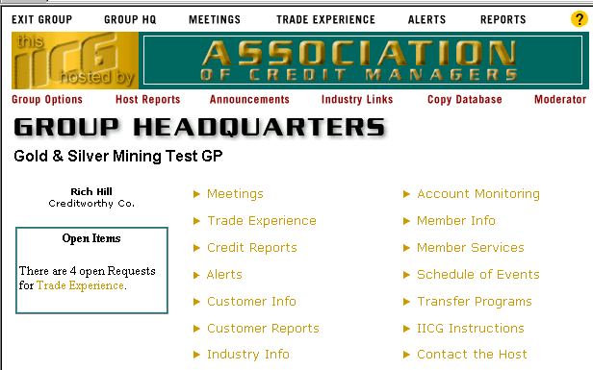

If you have a new account and want to pull an internally generated credit report, click on Credit Report. The report will contain demographic info, yearly pay scores, monthly trade experience summaries and detailed trade experience:

Company demographic information
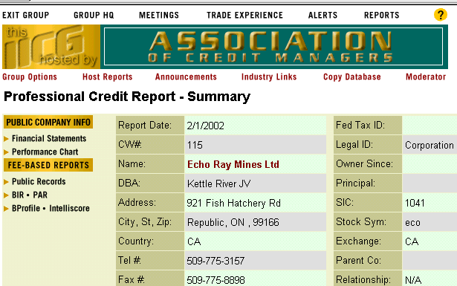
Yearly Pay Scores and Monthly Summaries
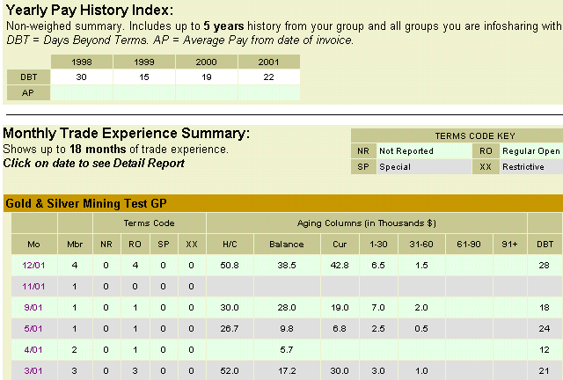

Detailed trade experience from each member
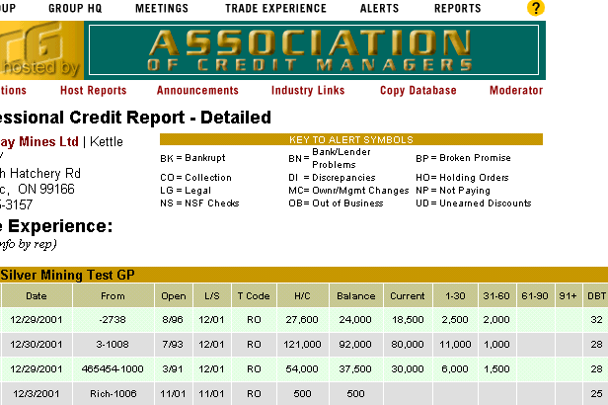

If the company is a U.S. or Canadian public company, you will have direct access to additional information such as financial statements, charts and news, etc.

If you feel that you do not have enough information to make a decision, click on Trade Experience to request additional trade experience from your fellow member. The request will be emailed to all members and those with experience will enter the group program to submit their experience:

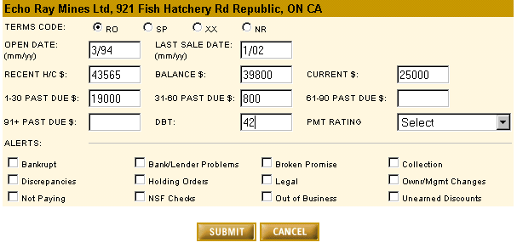

Within a couple of hours, the person who submitted the request should be able to return to obtain the new trade experience report!! Remember that all information is added to the database and to the Credit Report.

CREDIT ALERTS

Ok, you now have an updated report on that new customer, but now you get word that one of your customers has just bounced a large check to you. After talking to the customer, you find out that it wasn’t an accident. You are able to arrange for replacement check, but in order to warn the other members of the incident, you send an Alert. The members receive an email notification and the alert is added to the database.

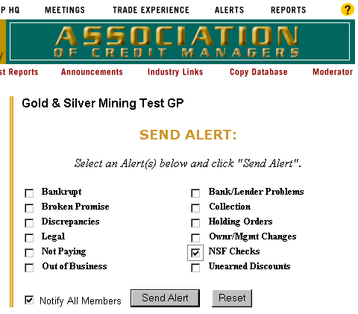

MEETINGS

A new day arrives and with it, you receive an email from the group host advising you of a meeting to be held next month. The notice lists 3 things to do: 1) submit names, 2) submit trade experience and 3) review the results and print it out and bring to the meeting to discuss with the other members. By going to the group program, all 3 of these processes are easily handled:

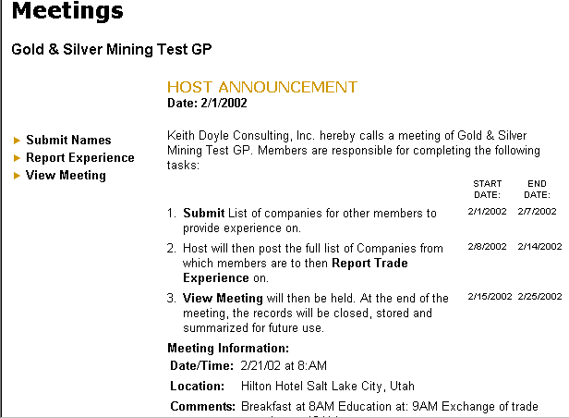

1) Select and submit names
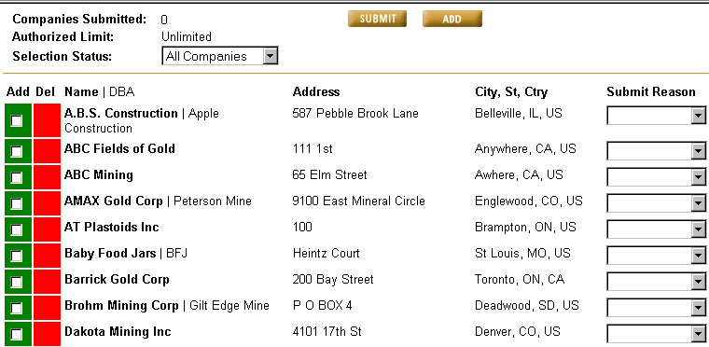
2) Submit Experience
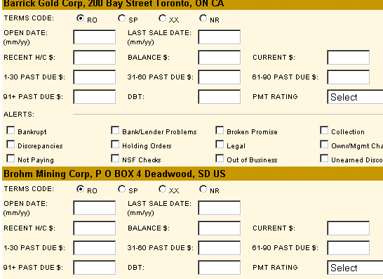
3) View and print trade experiences for meeting
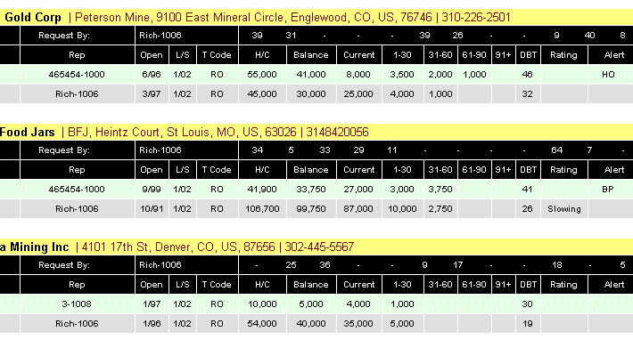

Note: we recommend members upload their trade experiences once a month so that manual entry is kept to a minimum.

CUSTOMER REPORTS

The Creditworthy Group Program provides 6 different reports. They are all valuable reports. Today you want to see how well your customers are paying. The Monthly Payment History Report will rank each customer by how well they paid. Here is an example:

DBT Scores are listed from best to worst
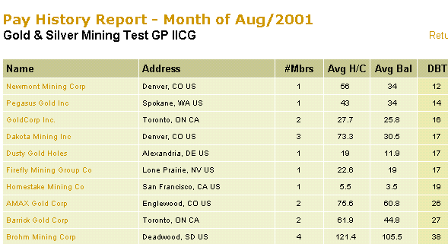

OTHER PROGRAM FEATURES

Account Monitoring Program. Select customers and once a month the program will send you payment history records. You can then import those records into your company database.

Customer Info. Add, edit and delete customers.

Industry Info. The group can identify special industry web sites that all group members will want to visit.

Member Info. Helps to identify all group members and representatives. We encourage all credit staff to join, not just one rep.

Transfer Programs. We encourage all members to transfer data into the group database as well as pull it from the group database to your company database. These pages will assist you in this endeavor.

IICG Instructions. New members will find these pages helpful in learning the program.

For more information:

Rich Hill / Creditworthy Co.
richh@creditworthy.com
503-694-5897

